1. Grade Checker
Take a score as input and print the grade based on the following:
90+ : "A"
80-89 : "B"
70-79 : "C"
60-69 : "D"
Below 60 : "F"
here we used a basic if else statement to carry out marks and all.

Solution~Screenshot
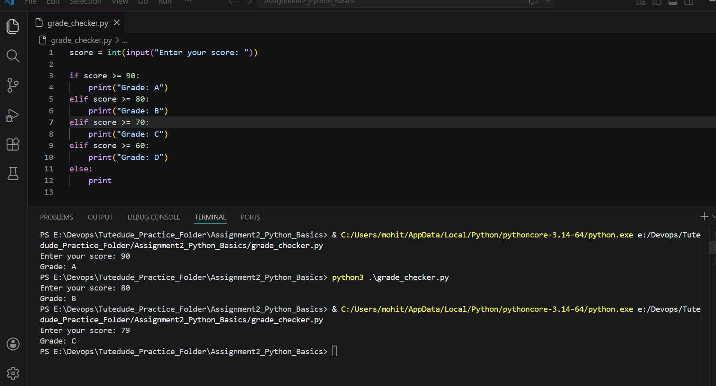
Explanation→ This program takes the score as input and uses if-elif-else conditions to print the grade.

2 Student Grades
Create a dictionary where the keys are student names and the values are their grades. Allow the user to:
Add a new student and grade.
Update an existing student’s grade.
Print all student grades
Used dictionary and basic operations. Using if else:

Solution~ Screenshot
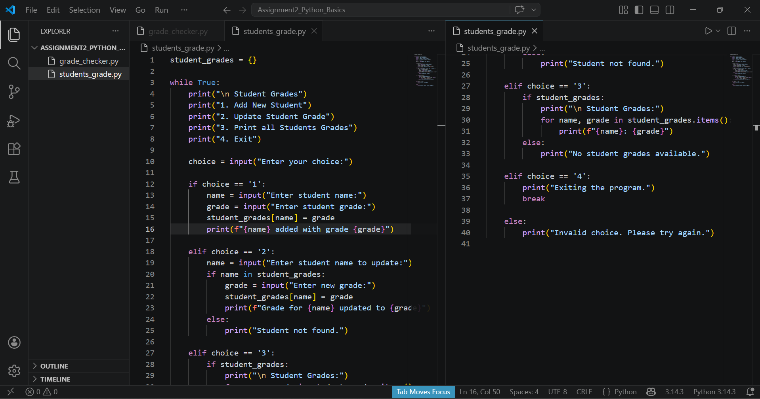
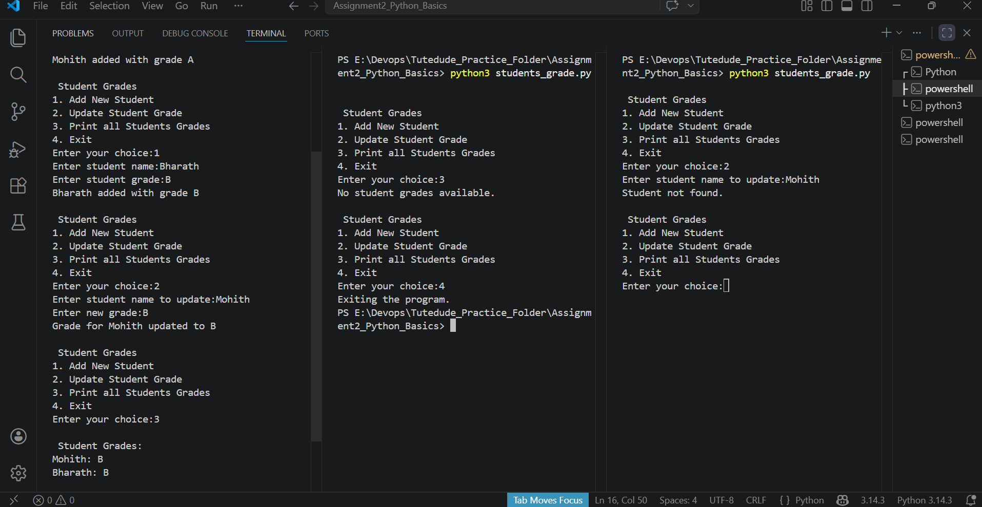
Explanation → This program uses a dictionary where:
- key = student name
- value = student grade
It allows the user to:
- add a student
- update a grade
- print all student grades

3.Write to a File
Write a program to create a text file and write some content to it.
Using file functions like write and open.

Solution~
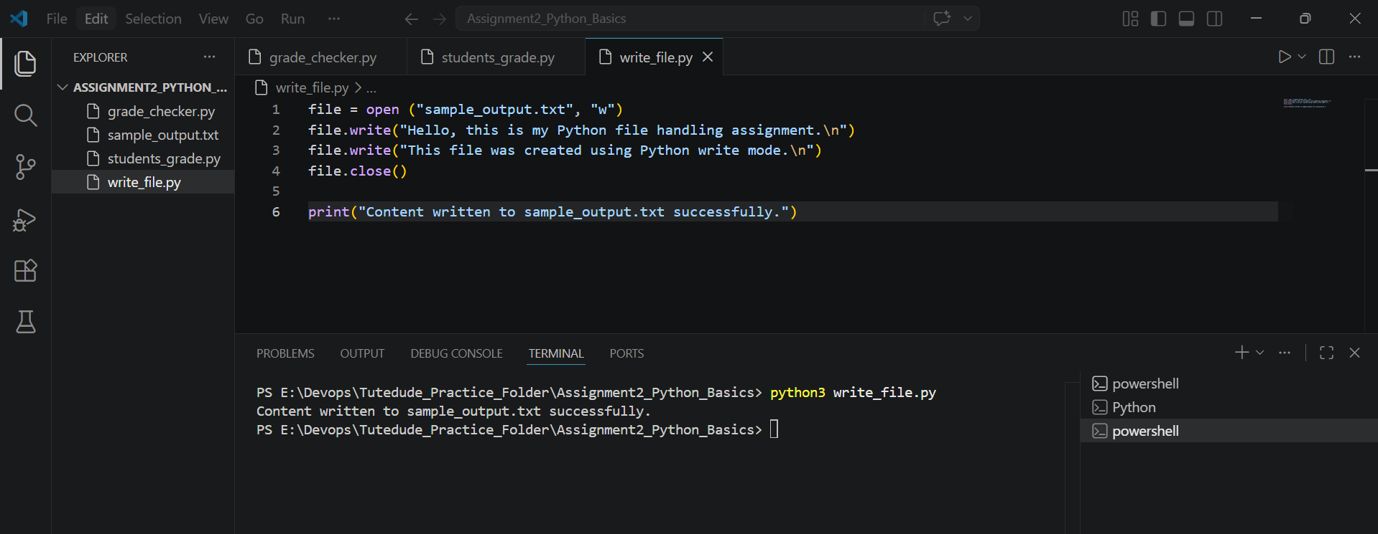
Explanation → This program creates a text file and writes content into it using:
- open() in write mode
- write()
- close()

4. Read from a File
We used open in read mode and file.read to read and print to display.

Solution~
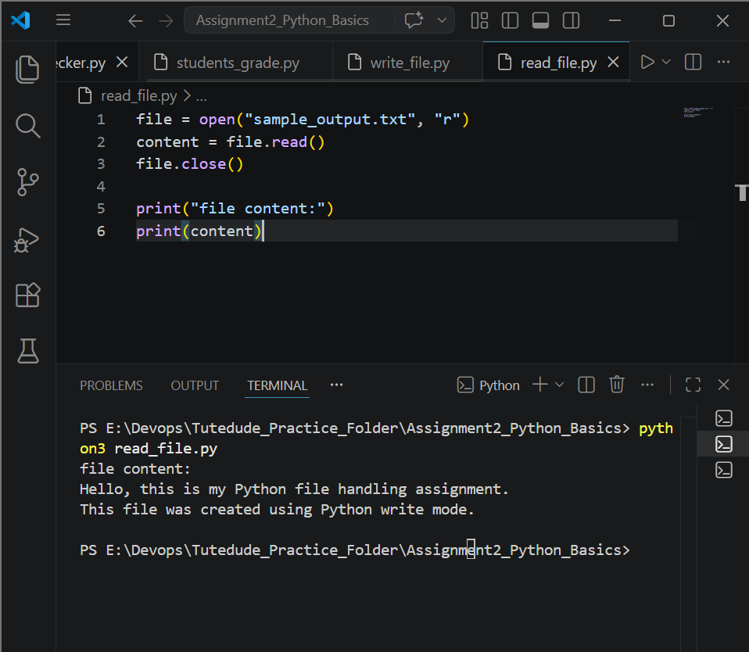
Explanation → This program opens the file in read mode, reads the content using read(), and prints it.

